Your First Hour with QuickBooks Online

Intuit's cloud-based accounting solutions get you up and running fast.

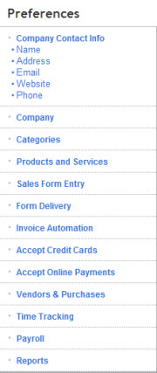
QuickBooks Online has been slowly evolving for over a decade, but one thing has remained constant: simplicity. These web-based versions - built from scratch, from the ground up - are friendlier, faster and even more flexible than the desktop editions.

Whether you're using the entry-level version (Online Simple Start) or the top-of-the-line option (Online Plus Payroll), you can create your company file and start creating invoices within an hour.

Sound overly ambitions? It's not.

Start Your Company File

When you log in for the first time you'll be invited to create an invoice. Skip this step and the Welcome screen. Instead, click the Company tab in the upper left, then the Preferences link in the row that opens below it. You'll see the vertical pane pictured to the left here.

Go ahead and fill in your Company Contact Info.

Next, click on Products and Services and make sure there's a check in the box next to Products and services for sale [and... for purchases]. Then click Save in the lower right corner.

You can add customer and vendor information "on the fly" ( as you're filling out invoices an purchase orders) and import existing lists from Excel and/or your email app, but let's create one to illustrate how easy it is to build records (which are then available to populate forms like invoices and purchase orders).

Build Your Records

Click the Customers tab. Close the message box about importing and click New Customer. Enter only contact information for now and save the record.

Click More | Products and Services List from the row below your main tabs, then select New in the lower right. You can import a list here, too, but for now, just type in information that describes something you sell. Next to Price/Rate, enter the price that you sell it for, not your cost. Leave the Income Account as Sales. (Accounting rules require you to have a Chart of Accounts that separate your income and expenses into related categories. Sales is one of them.)

If you purchase this product fro a vendor, check the box under Purchasing Information and enter the cost that you pay for the item. Leave the Expense account as is. Click Save.
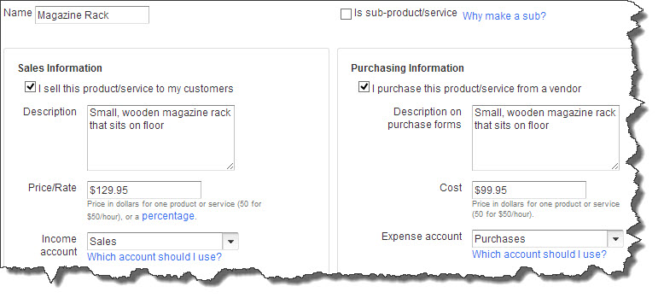
Figure 1: Creating an Item record. Throughout QuickBooks Online, you can click on blue text to get more information.
Fill in Your Form

Click Customers | Invoice. Click the arrow next to the Customer field and select your customer. You'll see that the contact information you entered is now displayed in the Bill To field. Click on the drop-down list in the first row under Product/Service and select your item. QBO fills in the description and price. If your invoice is complete as is, click Save, and you can email or print it.

But what if you want to sell more than one? Or charge sales tax? Or want to alter the Terms? QuickBooks Online can accommodate a wide variety of business needs. These option are covered in the Preferences window we worked with earlier, but you can also modify your invoices by clicking Customize in the upper right. This opens a mini-interview window that lets you address some of those issues.

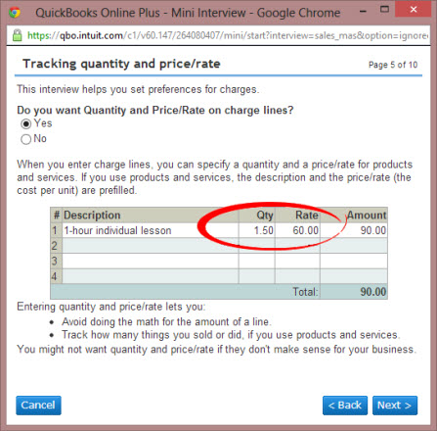
Figure 2: As you create your first invoice, you can customize QuickBooks Online to match your company's needs.
Desktop QuickBooks a Powerhouse
QuickBooks has come a long way since its introduction. In terms of features, it's roughly comparable to the desktop version of QuickBooks Pro. But QuickBooks Premier and Enterprise Solutions both have accounting tools not yet found in QBO, like advanced inventory management, sophisticated forecasting, multiple currency support, more reports and the ability to add additional simultaneous users.

On the other hand, QuickBooks Online offers unique features like:
- Free support
- Anytime/anywhere access
- Automatic backup and upgrades, and
- A superior user interface and navigational tools.
We've just scratched the surface of QuickBooks Online's capabilities here. And as simple and understandable is, you still need to understand some accounting concepts to use an accounting solution correctly. Want to learn more, or need help with your QBO operations? We're here.

